Chip back potential is the level which bulk silicon is maintained by on-chip connection, or it is the level to which the chip back must be connected when specifically stated below. If no potential is given the chip back should be isolated.

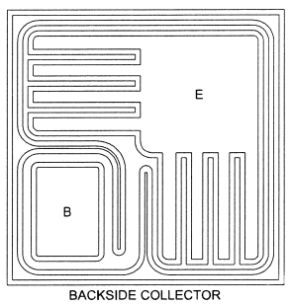
.080”
.080”

Top Material: Al
Backside Material: Ti Pd Ag
Base = .018” X .027”
Emitter = .034” X .034”
Backside Potential: COLLECTOR
Mask Ref: CP230

APPROVED BY: DK DIE SIZE .080” X .080” DATE: 11/17/21
MFG: CENTRAL SEMI THICKNESS .008” P/N: 2N6039
DG 10.1.2

Rev B, 7/19/02

